Identifying and characterizing alternative G•U wobbles resulting from rare protonation events in RNA.

Md. Sharear Saon1,2, Catherine A. Douds2,3, Andrew J. Veenis1,2, Neela Yennawar4, and Philip C. Bevilacqua1,2,3

1Dept of Chemistry, Penn State Univ, Univ Pk, PA 16802. 2Center for RNA Molecular Biology, Penn State Univ, Univ Pk, PA 16802. 3Dept of Biochemistry and Molecular Biology, Penn State Univ, Univ Pk, PA 16802, 4Huck Institutes of the Life Sciences, Penn State Univ, Univ Pk, PA 16802.

**Abstract:**

RNA can be an enzyme (ribozyme), small molecule sensor (riboswitch), and a vaccine. It may also have been critical to the original of life in the RNA world scenario. However, the molecular diversity of RNA is limited. A pressing question, therefore, is whether RNA can adopt other states such as novel protonation and tautomeric states. To date, covalent modifications of RNA have received widespread attention, but much less is known about any non-covalent alterations. Non-covalently modified nucleotides can be classified into charged and tautomeric forms, which involve changes in protonation state and proton location. These non-covalently modified nucleotides may provide additional stability to the RNA, with the formation of non-Watson-Crick base pairs and lend insights into unique regions in RNA molecules. We used a cheminformatic approach to study these non-covalent changes to the bases and propose one novel orientation of G•U wobble base pairs, which requires the U to be negatively charged or rare enol tautomer. We identified four structure families containing shifted wobbles within bacterial rRNA. The computational pipeline from our study can be followed with different set of structures and filtration criteria to identify different sets of structure families.

**Introduction:**

**Results:**

1. Identifying shifted wobble pairs:

As of April 2023, the RCSB Protein Data Bank contained 6,817 RNA structure files in Crystallographic Information File (CIF) format. These structures were solved using various methods, with 3,729 by X-ray diffraction, 2,331 by Electron Microscopy, 737 by solution NMR, and 20 by other experimental techniques. After applying a 3.2 Å resolution cutoff, 3,915 structure files (3038 were solved by X-ray diffraction, 875 were solved by Electron Microscopy and 2 were solved by Fiber diffraction) were selected for further characterization.Within these 3,709 structures, DSSR analysis revealed the presence of 389,175 A•U, 899,418 G•C, and 159,047 G•U base pairs (121,476 wobbles or standard wobbles and 37,571 non-wobbles). The non-wobble G•U pairs were analyzed for hydrogen bonds between N1 of G and O4 of U, as well as N2 of G and N3 of U (see Figure 1), resulting in the identification of 1,117 shifted wobble pairs.Both from the standard wobble and shifted wobble datasets, excluding examples where base pair forming residues are from different chains and examples with residue index containing insertion code resulted 119,839 standard wobble and 1,114 shifted wobbles. After applying the three step quality assessment described in the 2C of ‘materials and methods’, the total number of standard wobble and shifted wobble examples were 70,579 and 373, respectively. In these datasets of standard and shifted wobbles, an overrepresentation of certain wobble examples and an underrepresentation of others were observed. (note for me: provide at least one examples from the over representation and underrepresentation examples) To prevent any misleading conclusions, representative structures were identified for each wobble with multiple available examples by following the steps described in subsection of ‘materials and methods’ section. From the redundancy filtration, the data size for the non-redundant standard and shifted wobbles were 5,951 and 41, respectively.

1. Confirmation of the shifted wobble orientation

The hydrogen bonds required for the formation of standard wobbles are between O6 of G and N3 of U (O6-N3), and between N1 of G and O2 of U (N1-O2). In contrast, the hydrogen bonds necessary for the formation of shifted wobbles are between N1 of G and O4 of U (N1-O4), and between N2 of G and N3 of U (N2-N3). From Figure 4, the distance distribution for O6-N3 and N1-O2 in both standard and shifted wobbles is as expected. These distances are within 3.4 Å for standard wobbles but range from 5-6 Å for shifted wobbles. Similarly, the N1-O4 and N2-N3 distances are within 3.4 Å for shifted wobbles but range from 5-6 Å for standard wobbles. This cross-comparison of the distances between atoms forming the hydrogen bonds in the wobbles reinforces confidence in the structures of the shifted wobbles. The correlation coefficients between the model and electron density map for the 41 non-redundant examples of shifted wobbles (refer to SI Figure #) provide further validation for the 3D structures analyzed in this study.

1. Trends in primary and secondary structures:

From flanking sequence and base pair information of the structure containing shifted wobbles, 35 out of 41 non-redundant examples were identified at the terminal of a stem (figure 5).

* 1. From figure 6, it was found that Watson-Crick-Franklin base pair is preferred at the immediate above or below position of shifted wobbles.
  2. Later, it was also found that 35 out of 41 non-redundant examples contain at least one Watson-Crick-Franklin base pair at immediate above or below of shifted wobbles.

1. Trends in tertiary structures:

To identify clusters with similar 3D structures where residues forming shifted wobbles are from the same location of the same RNA, a RMSD cut-off of 1.23 Å was applied.

* 1. Four clusters containing at least four similar structures were identified.
  2. Structural features of each cluster:
     1. Cluster 1 (N=9):
        1. 8 structures are from bacterial 16S rRNA
        2. One structure (PDB ID: 7QEP) is from eukaryotic 18S rRNA
        3. Sequences of the chain containing these shifted wobbles were aligned against E. coli 16S which confirms the fact that all these wobbles are from the same location of rRNA (Figure 7A).
        4. All structures are forming U•G shifted wobbles (Figure 7A and 8)
        5. In all structures wobbles are found at the end of a stem. Residues enclosed by the shifted wobbles are forming a multiloop junction (not sure about the name) with hairpin of eight nucleotides at the end (Figure 7A).
        6. Both G and U are highly stacked with residue from above and below (Figure 8)
        7. Non-Watson-Crick-Franklin interaction between O2 of U and O2’ of A from 5’-end of U (Figure 8).
        8. Non-Watson-Crick-Franklin interaction between O2’ of G and O4’ of G from 3’-end of G (Figure 8).
        9. Non-Watson-Crick-Franklin interaction between O4 of U and O4 of U from 3’ end of U (Figure 8).
        10. Note for me: calculate average distance between structures in this cluster
     2. Cluster 2 (N=4):
        1. Three structures are from bacterial 23S rRNA
        2. One structure (PDB ID: 5MMI) is from eukaryotic 23S rRNA
        3. Sequences of the chain containing these shifted wobbles were aligned against E. coli 23S which confirms the fact that all these wobbles are from the same location of rRNA (Figure 7B).
        4. All structures are forming G•U shifted wobbles (Figure 7B and 8)
        5. In all structures wobbles are found at the first mismatch position of a hairpin of 11 nucleotides (Figure 7B).
        6. Both G and U are highly stacked with residue from above and below (Figure 8)
        7. Potential A+C mismatch right above the wobble (Figure 7B and 8)
           1. G is highly stacked with the residues both from the 5’ and 3’ end of the strand
           2. U has stacking interaction with the residue from the 5’ end of the strand
           3. In all structures hydrogen bond is observed between the N6 of A and N1 of C
           4. Note for me: need to analyze for any anion–π interaction.
        8. Note for me: calculate average distance between structures in this cluster
     3. Cluster 3 (N=5):
        1. All structures are from bacterial 16S rRNA
        2. Sequences of the chain containing these shifted wobbles were aligned against E. coli 16S which confirms the fact that all these wobbles are from the same location of rRNA (Figure 7C).
        3. All structures are forming U•G shifted wobbles (Figure 7C and 8)
        4. In all structures wobbles are found at the end of a stem. Residues enclosed by the shifted wobbles are forming a stem-loop (hairpin of six nucleotides) structure (figure 7C).
        5. No stacking interaction involved with U (Figure 8)
        6. G is highly stacked with residues from above and below (Figure 8).
        7. No consistent non-Watson-Crick-Franklin interaction was observed (Figure 8).
        8. Note for me: calculate average distance between structures in this cluster
     4. Cluster 4 (N=6):
        1. structures are from bacterial 23S rRNA
        2. Sequences of the chain containing these shifted wobbles were aligned against E. coli 23S which confirms the fact that all these wobbles are from the same location of rRNA (Figure 7D).
        3. All structures are forming G•U shifted wobbles (Figure 7D and 8)
        4. In all structures wobbles are found at the first mismatch position of a hairpin of nine nucleotides (Figure 7D).
        5. Both G and U have stacking interaction with the residues from the bottom
        6. Non-Watson-Crick-Franklin interaction between O4’ of U and O2’ of A from the 5’ end of U.
        7. A lot of non-Watson-Crick-Franklin interaction between shifted wobble residues and amino acid residues were observed.
        8. Note for me: calculate average distance between structures in this cluster
  3. Structural features of non-clustered shifted wobbles: (Note for me: not analyzed yet)
  4. Note for me: any observation from torsional angles?

**Discussions:**

Structural features of the clusters supporting the formation of shifted wobbles:

1. Contribution from stacking interaction
2. Contribution from backbone interaction
3. Any consistent non-Watson-Crick-Franklin interaction?

Future direction:

**Materials and methods:**

1. Workflow to identify non-redundant shifted wobbles
   1. Downloading and characterizing RNA structures

The workflow started with collecting structures containing RNA entities from the RCSB protein data bank (ref). Because of the number of atom limitation in the ‘Protein Data Bank’ pdb format, structures were be collected in ‘Crystallographic Information File’ (cif) format. An initial resolution cut-off (3.2 Å) was applied to ensure the satisfactory quality of structures for future analysis. This resolution cut-off should exclude all the structures solved by solution NMR method. The selected structures were then characterized by the Dissecting the Spatial Structure of RNA (DSSR) software. This step will output base pair, hydrogen bond, stacking, glycosidic angle, sugar pucker information for each structure files.

* 1. Identifying wobbles based on hydrogen bonds

From the base pair information all G•U base pair were identified and filtered to wobble and non-wobble base pairs. All wobbles were considered for next steps of analysis as standard wobbles. Any non-wobble base pairs containing hydrogen bonds between N1 of G and O4 of U, as well as N2 of G and N3 of U (see Figure 1) was binned to shifted wobble base pairs.

* 1. Additional data extraction, calculation, and filtration

For all the standard and shifted wobble base pairs, two step data extraction were performed. In the first step, metadata of the solved structures containing the wobbles were extracted from RCSB protein databank. These data include name of source and expressed organism, type of RNA molecule, segment ID, and length of the reference chain. In the next step, three types of information were calculated for each wobble: distances, dihedral angles, and average temperature factors. To calculate distances, three atoms (O6, N1, and N2) from the Watson-Crick-Franklin edge of G and three atoms (O4, N3, and O4) from the Watson-Crick-Franklin edge of U were considered. For each atom, the distances to the three Watson-Crick-Franklin atoms of the other residue were calculated, resulting in a total of nine distances: N1-O2, N1-N3, N1-O4, N2-O2, N2-N3, N2-O4, O6-O2, O6-N3, and O6-O4, where the atom before hyphen and the atom after hyphen are associated to G and U, respectively. To evaluate the coplanarity of the G and U, dihedral angles were calculated for two distances of the hydrogen bonds required for the wobbles and for O6-O4. For standard wobbles two hydrogen bond distances are O6-N3 and N1-O2. For shifted wobbles two hydrogen bond distances are N1-O4 and N2-N3. Finally, the average temperature factors for the nucleobase atoms of G and U forming the wobbles were calculated. (note for me, need to make a new figure, showing 9 distances and three dihedral angles)

Using the calculated structural parameters, both standard and shifted wobble base pairs were evaluated for the quality of hydrogen bonds and solved structures through three step quality check process. Structures passing the first step of the quality check had hydrogen bond distances of 3.4 Å or less and dihedral angles of 50° or less. In the next step, structures with a temperature factor exceeding 100 for either G or U were excluded from the next step. Finally, any examples with an O6 of G to O4 of U distance of 3.4 Å or less were filtered out to prevent the inclusion of wobbles with unclear orientations.

Structures from the previous step were analyzed to check the consistency of the residue index. (from Katie).

* + 1. Flanking sequences above and below of shifted wobbles were also extracted in this step.
  1. Identifying representative structures for redundant examples

From the dataset of structures, one can expect the lack of uniformity of structures in terms of source organism and RNA type. Therefore, for each group of structures from same organism and RNA type with same residue index, following filtration steps were followed to identify one representative structure. However, because sequence indexes did not always match between structures of the same RNA in the same organism, indexes were first adjusted by alignment to one reference sequence for each organism and RNA type. Alignments were performed with EMBOSS needle. -Katie. From the first filtration onward, the workflow would advance only if multiple structures successfully passed the preceding filtration step.

Filtration 1: Only structures solved by X-ray diffraction would be considered for the next step, unless no such structures are available.

Filtration 2: Structures with less than 90% of the highest resolution were excluded.

Filtration 3: Structures were excluded if the chains containing the standard or shifted wobbles of interest were less than 85% of the maximum chain length in the group.

Filtration 4: Structures with best temperature factors for both G and U would be considered for the next step.

If multiple structures are available after the four filtration steps, then representative structures were selected randomly.

* 1. Checking the quality of the structure model:

For all non-redundant examples, electron density files of the corresponding RNA structures were collected from RCSB protein databank. From COOT software package, correlation between electron density and model (structure) were calculated.

1. Analysis of wobbles
   1. Identifying non-WCF interactions for selected atoms

Using PyMOL API for python, non-Watson-Crick-Franklin interactions within 3.4 Å of O2’, O4’, N2, N3, O6, and N7 of G and O2’, O4’, O2, and O4 of U were identified for all the non-redundant shifted wobbles.

* 1. Extracting structural features from DSSR characterization output

From DSSR characterization output, sugar pucker, glycosidic angle, stacking interaction, and torsional angles information were extracted for both G and U forming shifted wobbles.

* 1. Identifying location in secondary structure motifs
     1. Based on the base pair information extracted from DSSR characterization output, type of closest base pair above and below of the shifted wobble were checked to bin wobbles based on their location in one of the five secondary structure motifs: stem, terminal above, terminal below, unstructured, and inside loop.
  2. Identifying and analyzing clusters with similar structures

To identify group of shifted wobbles, structure motifs were clipped with one residue above and below of both G and U. These motifs contained six residues. To compare structures with each other, pairwise RMSD were calculated using biopython’s superimposer library which require structures to contain same number of atoms. When comparing two structures, differences in the total number of atoms can result from missing atoms or differences in sequences. To address the first issue, only residues without missing coordinates for any atoms were considered. The selected atoms were P from phosphate and C4’ from sugar, for purine C2, C6, and N9 and for pyrimidine N1, C2, and C6 were considered.

1. Experimental: DMS reactivity from Katie

Table1: frequency of standard and shifted wobbles in 3D structures available in protein databank

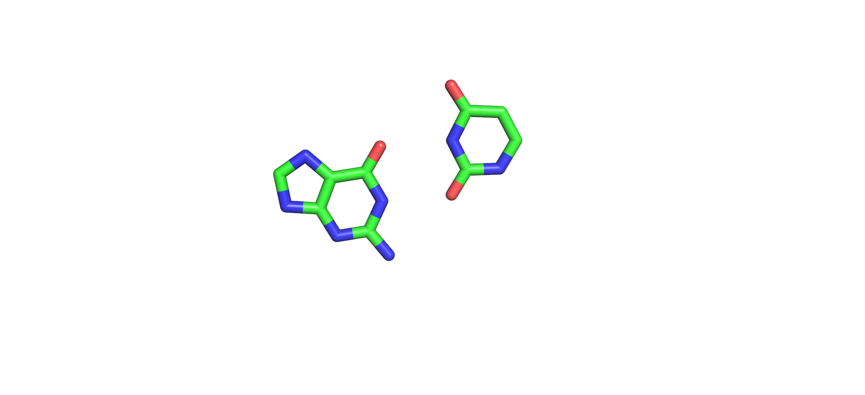

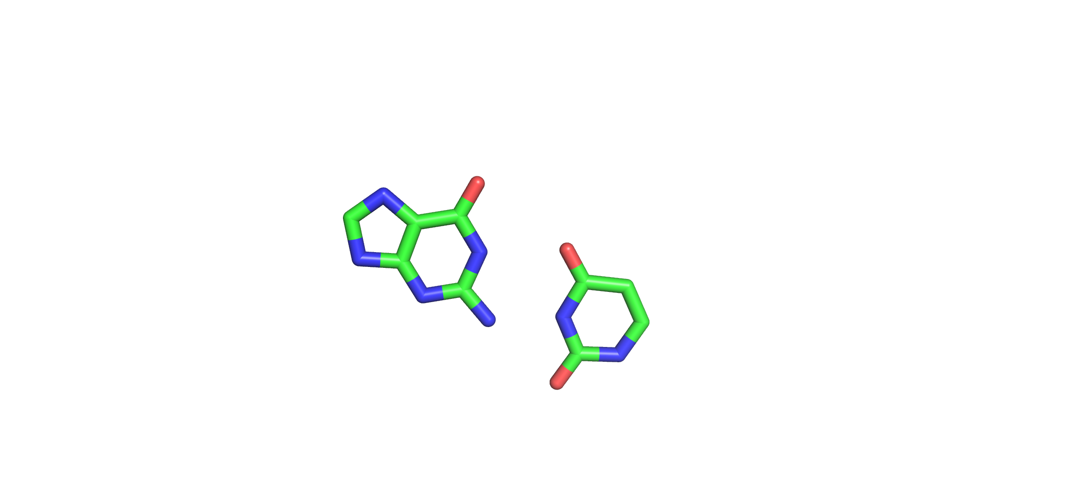

1

2

3

4

5

6

7

8

9

1

2

3

4

5

6

Anionic

Standard G•U wobble

Shifted G•U wobble

Enol tautomeric

A

B

-

Figure 1: (A) Standard and (B) shifted charged (top), tautomeric (bottom) wobbles between G and U.

Downloading and characterizing RNA structures

Identifying wobbles based on hydrogen bonds

Identifying representative structures for redundant examples

Additional data extraction, calculation, cleaning, and filtration

Identifying non-Watson-Crick-Franklin interactions for selected atoms

Extracting structural features from DSSR characterization output

Identifying location in secondary structure motifs

Identifying and analyzing clusters with similar structures

Analysis Steps

Steps for identifying non-redundant examples of shifted wobbles

A

B

Figure 2: Complete workflow of identifying (panel A, top green box) and analyzing (panel B, bottom blue box) non-redundant shifted wobbles. Three atom pairs from the nucleotides, for which distances and dihedral angles were calculated, are highlighted with red lines in panel C. Base pair in panel C are shown with U-O2 enol tautomeric form.

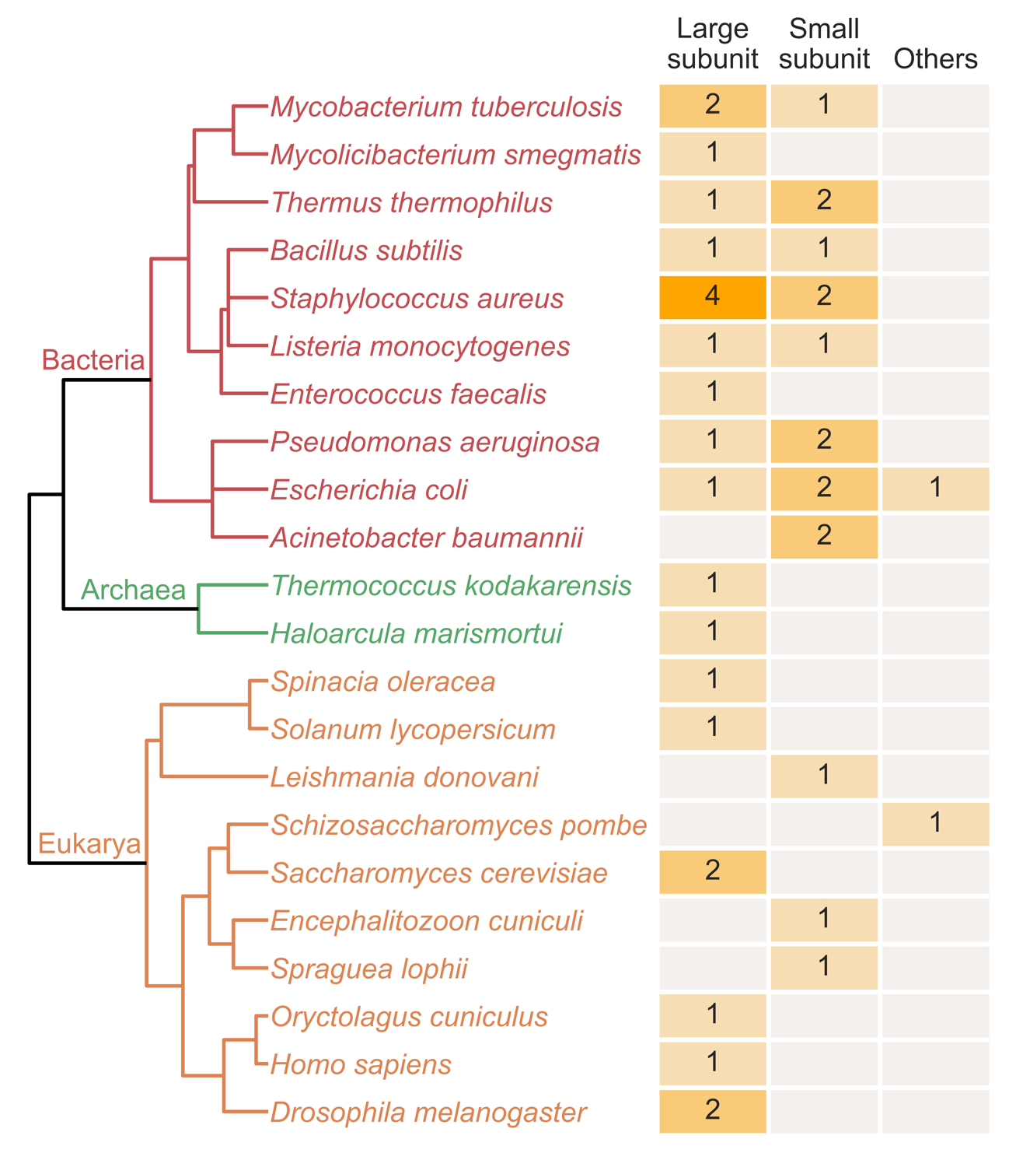

Figure 3: Distribution of source organism and RNA type for the 41 non-redundant structures containing shifted wobbles. The gray boxes indicate no data is available for the corresponding RNA types and organisms. The ‘Other’ column contains structure from a 75-mer and a sgRNA. (Note for me: one table showing the count of shifted wobbles against standard wobbles will be prepare

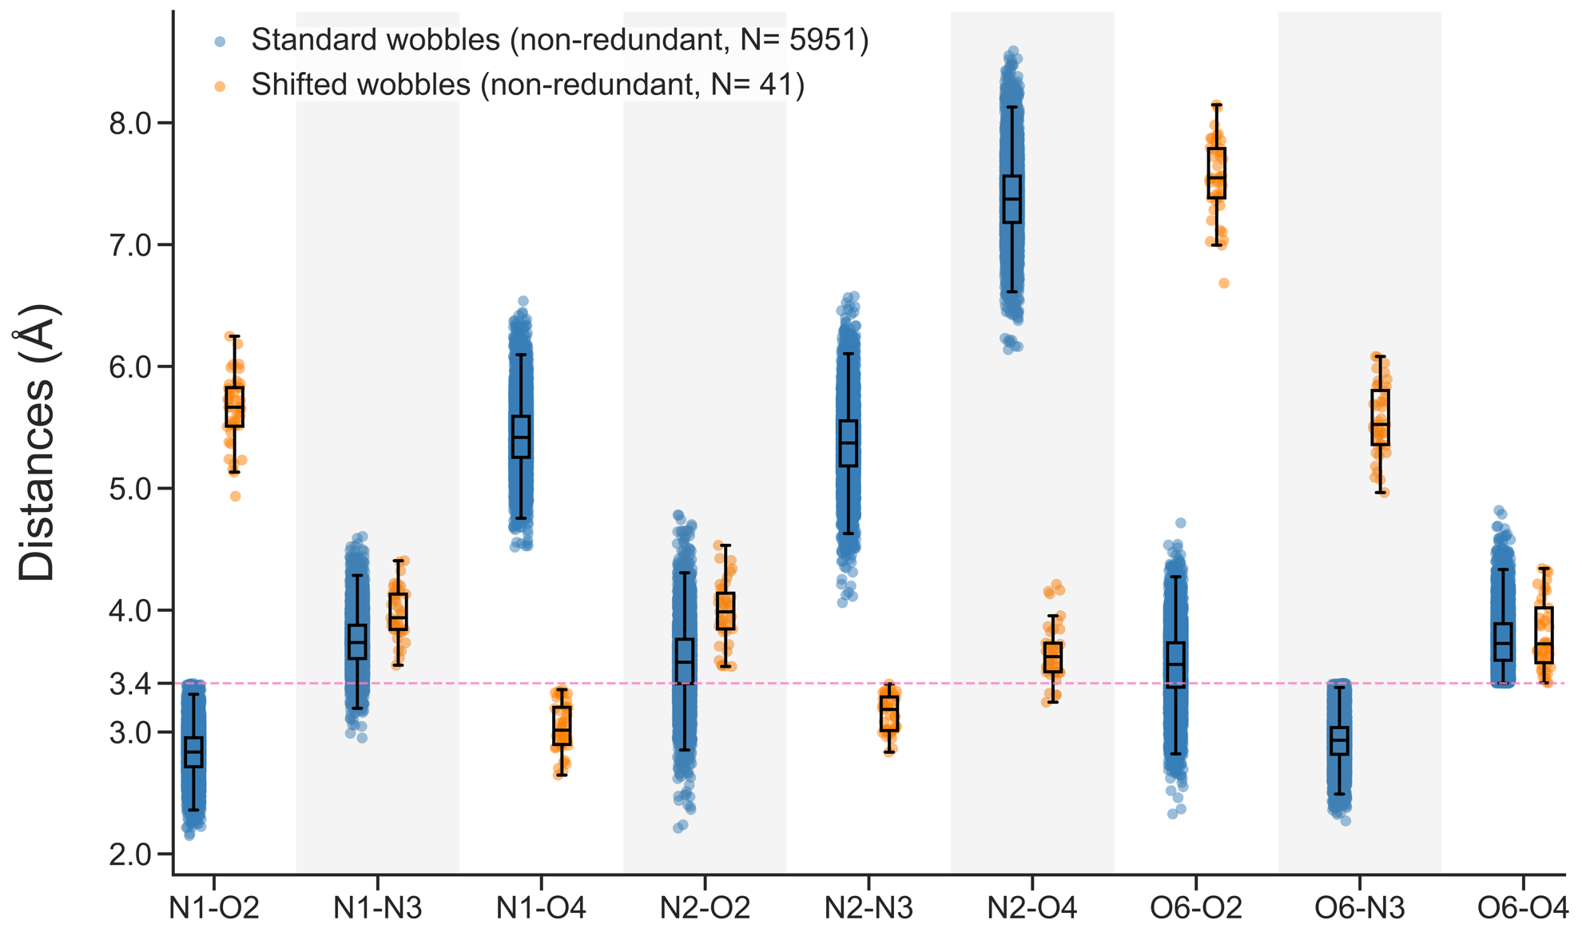

Figure 4: Distribution of nine distances from three Watson-Crick-Franklin edge atoms (N1, N2, O6) of G to three Watson-Crick-Franklin edge atoms (O2, N3, O4) of U.



0

-1

-2

1

2

Wobble

5’

5’

3’

3’

A

B

C

Figure 5: Patterns in flanking sequences two steps above and below of shifted wobbles. In panel A, simplified 2D structures of shifted wobbles (in while circles) and corresponding flanking sequences (red circles for one step next to shifted wobbles, blue circles for two steps next to shifted wobbles) are shown. Panel B and C are representing the G•U and U•G wobbles flanking sequence pattern in line graph. In the line graph, X-axis is representing the flanking position relative to wobble and Y-axis is representing the sequence of the corresponding flanking position.

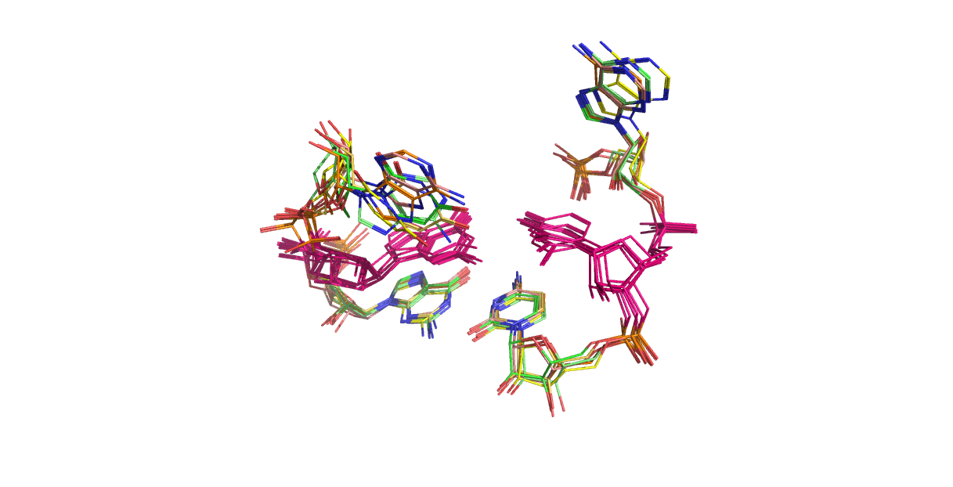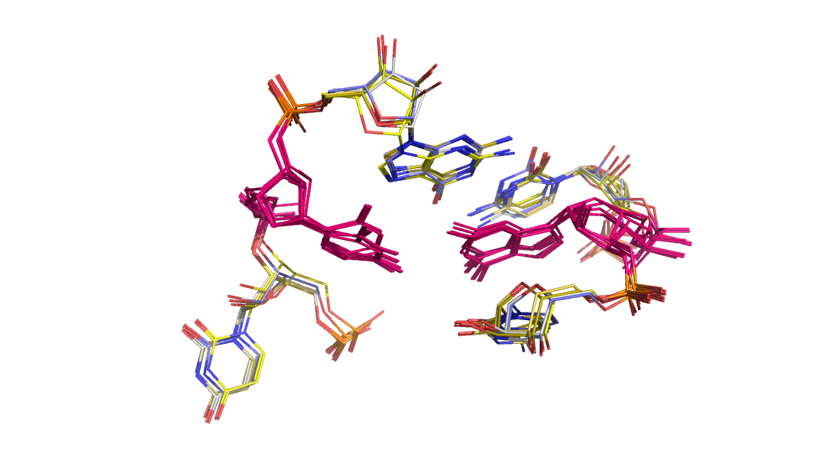

Cluster 1

N= 9

Cluster 2

N= 4

Cluster 3

N= 5

Cluster 4

N= 6

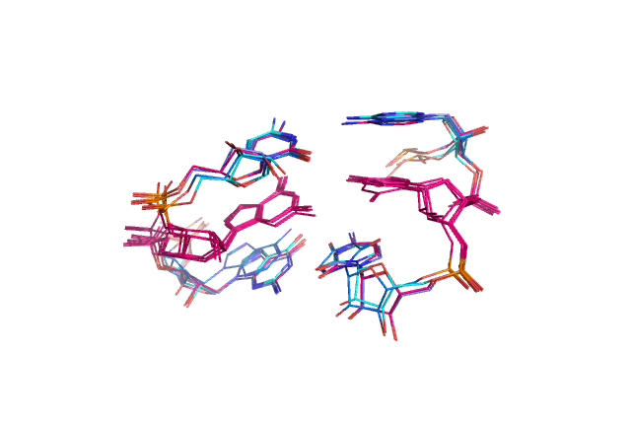

Figure 6: Dendrogram representing distances between non-redundant shifted wobbles and clusters within 1.23 Å RMSD cut-off. Distances were calculated from all-against-all structure alignment. In the corresponding aligned structures of a cluster, pink residues are representing the residues forming shifted wobbles. (Note for me: we might need to explain the filename convention shown as leaves in the dendrogram)

K= G or U, M= A or C, S= G or C, V= A or C or G, W= A or U, Y= C or U

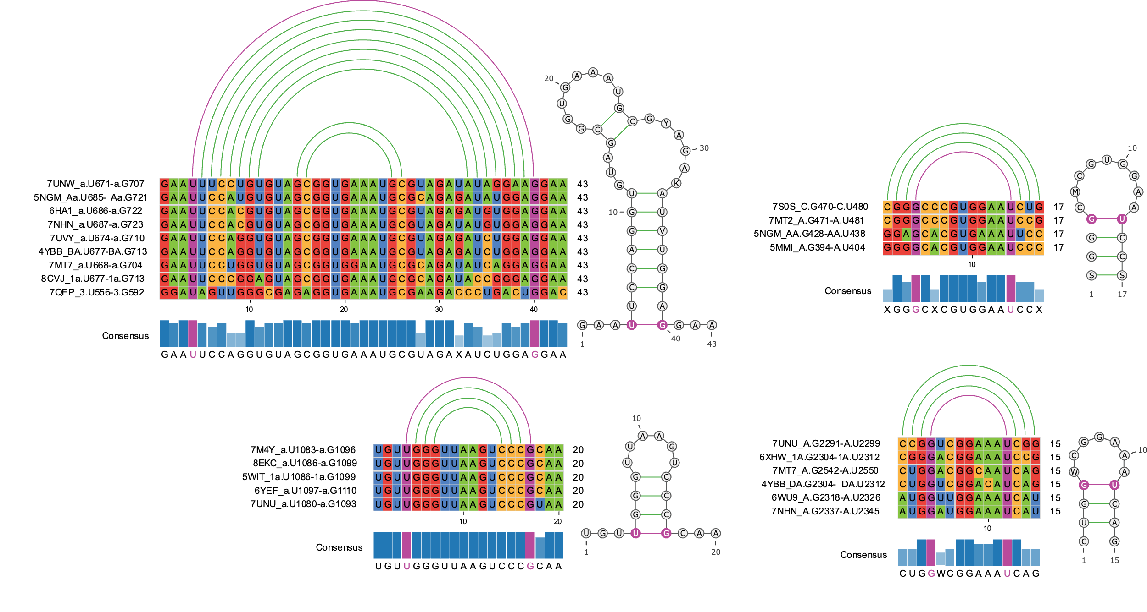

Cluster 1 (N= 9)

Cluster 2 (N= 4)

Cluster 3 (N= 5)

Cluster 4 (N= 6)

A

B

D

C

Figure 7: Consensus sequences and secondary structures formed by the residues enclosed by the shifted wobbles of the four clusters. Structural information of cluster 1, 2, 3, and 4 are shown in panel A, B, C, and D, respectively. Arch view of secondary structure drawn by R-chie webtool (ref), multiple sequence alignment were performed and plotted using pyMSAviz python package (ref), radiate planer representation of the secondary structures were prepared by using VARNA java applet (ref), and the consensus sequences were assigned by the Cavener rule (ref).



Major groove atoms

Minor groove atoms

Sugar atoms



Major groove atoms

Minor groove atoms

Sugar atoms



Major groove atoms

Minor groove atoms

Sugar atoms



Cluster 1

N= 9

Cluster 2

N= 4

Cluster 3

N= 5

Cluster 4

N= 6

Major groove atoms

Minor groove atoms

Sugar atoms



Figure 8: Aligned 3D structures of the four clusters and heatmaps to show the non-Watson-Crick-Franklin interactions within 3.4 Å of the atoms mentioned in the Y-axis of the heatmaps. (Note for me: for simple visualization we can show the structure of the representative structure of a cluster.

Figure 8:



*E. Coli 16S rRNA*



DMS   
Reactivity

U677

Figure 9: DMS reactivity of *E. coli* 16S indicating the formation of charged shifted wobbles.

SI Figures:

Repeat for all 41 non-redundant shifted wobbles

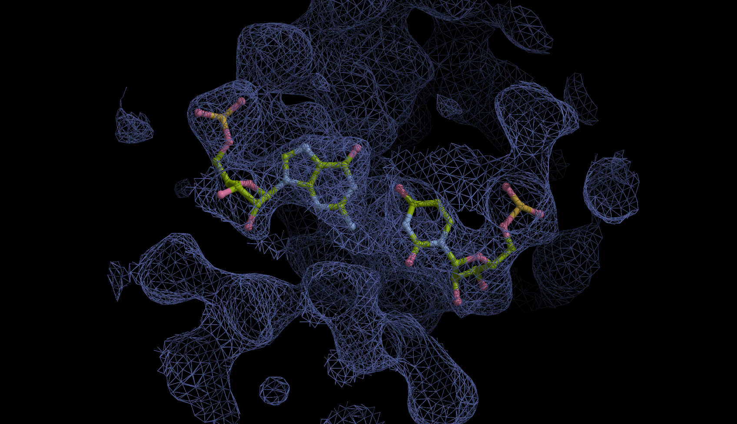

cc= 0.42

cc= 0.37

4YBB_BA.U677-BA.G713

Figure 1: Correlation coefficient (cc) between electron density map and model (structures) of all 41 non-redundant shifted wobbles.